Software Requirements
Specification
for
Smart Land Ownership Verification and Encumbrance portal

Prepared by
MONIKA B (24CSR184)
MOONIKA SRI R (24CSR187)
NATCHATHRA R(24CSR197)
NISHA SHREE B(24CSR209)

KONGU ENGINEERING COLLEGE

17.07.2026

Table of Contents
Table of Contents ii
- Introduction 1
  - Purpose 1
  - Document Conventions 1
  - Intended Audience and Reading Suggestions 1
  - Product Scope 1
  - References 1
- Overall Description 2
  - Product Perspective 2
  - Product Functions 2
  - User Classes and Characteristics 2
  - Operating Environment……………………………………………………………………………..3
  - Design and Implementation Constraints 3
  - User Documentation 3
  - Assumptions and Dependencies 3
- External Interface Requirements 4
  - User Interfaces 4
  - Hardware Interfaces 4
  - Software Interfaces 4
  - Communication Interface…………………………………………………………………………...5
- System Features………………………………………………………………………………..6
  - User Registration……………………………………………………………………………………6
  - User Authentication 7
  - Land Record Search 7
  - Ownership Verification 8
  - Encumbrance Verification………………………………………………………………………….9
  - Document Upload…………………………………………………………………………………..9
  - OCR-based Data Extraction……………………………………………………………………….10
  - Verification Report Generation……………………………………………………………………10
  - Admin Management……………………………………………………………………………….11
- Other Nonfunctional Requirements 12
  - Performance Requirements 12
  - Safety Requirements 12
  - Security Requirements 12
  - Availability Requirements 12
  - Maintainability…………………………………………………………………………………….12
  - Scalability………………………………………………………………………………………….12
  - Business Rules ….12
- Other Requirements 13
  - Database Requirements 13
  - Privacy Requirements 13
  - Legal Requirements 13
Appendix A: Analysis Models 14
Use Case Diagram………………………………………………………………………………14
Activity Diagram………………………………………………………………………………..15
Sequence Diagram………………………………………………………………………………16
ER Diagram……………………………………………………………………………………..17
DFD………………………………………………………………………………………………18
System Architecture…………………………………………………………………………….19
Appendix B: Issused List 19

Introduction

Purpose

The Smart Land Ownership Verification and Encumbrance Portal is designed to provide a secure and efficient platform for verifying land ownership details and checking encumbrance information. The system enables users to upload land-related documents, verify ownership details against stored records, and obtain accurate encumbrance information. The portal aims to reduce property fraud, improve transparency in land transactions, and simplify the land verification process for buyers, sellers, and government authorities.

Document Conventions

This Software Requirements Specification (SRS) follows the IEEE standard for documenting software requirements.
The following conventions are used throughout this document:

- SHALL indicates mandatory system requirements.
- SHOULD indicates recommended requirements.
- MAY indicates optional requirements.
- OCR refers to Optical Character Recognition.
- EC refers to Encumbrance Certificate.

Intended Audience and Reading Suggestions

This document is intended for:
- Software Developers
- Database Administrators
- Project Guide
- Testing Team
- System Administrators
- End Users
- Government Authorities responsible for land record management
Readers are encouraged to begin with the Introduction section before proceeding to the functional and non-functional requirements.

Product Scope

The Smart Land Ownership Verification and Encumbrance Portal provides a centralized web-based platform for verifying land ownership information and checking encumbrance details. Users can search land records, upload land-related documents, extract document information using OCR technology, compare the extracted details with stored records, and generate verification reports. The system improves efficiency, minimizes manual verification efforts, and enhances transparency in property transactions.

Overall Description

Product Perspective

The Smart Land Ownership Verification and Encumbrance Portal is a web-based application designed to simplify and digitize the process of land ownership verification and encumbrance checking. The system provides a centralized platform where users can search land records, upload land-related documents, verify ownership details, and check encumbrance status. It reduces manual verification efforts, minimizes fraudulent property transactions, and improves transparency in land management.

Product Functions

The system shall provide the following functions:
- User registration and secure login.
- Search land records using Survey Number, Patta Number, Registration Number, or Owner Name.
- Upload land-related documents such as Sale Deed, Patta, Chitta, and Encumbrance Certificate.
- Extract document information using Optical Character Recognition (OCR).
- Verify ownership details by comparing extracted information with stored land records.
- Check encumbrance status of a property.
- Generate downloadable verification reports.
- Maintain user verification history.
- Allow administrators to manage land records, ownership information, and encumbrance details.
- Provide notifications for successful verification and document status updates.

User Classes and Characteristics

Citizen
- Register and log in securely.
- Search for land ownership information.
- Upload land documents.
- Verify ownership and encumbrance status.
- Download verification reports.
Administrators
- Manage user accounts.
- Add, update, or delete land records.
- Manage ownership information.
- Update encumbrance records.
- Review uploaded documents.
- Generate system reports.

2.4 Operating Environment

Hardware
- Desktop Computer or Laptop
- Smartphone or Tablet
- Internet Connection

Software
- Windows/Linux/macOS
- Modern Web Browser (Google Chrome, Microsoft Edge, Mozilla Firefox)
- React.js
- Python Flask/FastAPI
- MySQL Server

Database
- MySQL

2.5 Design and Implementation Constraints

- The system requires a stable internet connection.
- Only authenticated users can access protected features.
- OCR accuracy depends on the quality of uploaded documents.
- The application is developed using React, Flask/FastAPI, and MySQL.
- Uploaded documents should be in PDF, JPG, JPEG, or PNG format.
- The project uses a sample land records database for academic purposes.

2.6 User Documentation

The following documents will be provided:
- User Manual
- Administrator Guide
- Installation Guide
- System Configuration Guide

2.7 Assumptions and Dependencies

- Users have internet connectivity.
- Land records are available in the system database.
- OCR libraries are properly configured.
- The database server is operational.
- Users upload clear and readable land documents.

The application is intended for educational and prototype purposes.

3. External Interface Requirements

User Interfaces

Citizen Interface

Features:
- User Registration
- User Login
- Search Land Records
- Upload Land Documents
- Ownership Verification
- Encumbrance Status
- Verification Report Download
- User Profile
- Verification History
Administrator Interface

Features:
- Admin Login
- Dashboard
- Manage Users
- Manage Land Records
- Manage Ownership Records
- Manage Encumbrance Records
- Verify Uploaded Documents
- Generate Reports
- System Analytics

Hardware Interfaces
- Desktop/Laptop
- Smartphone/Tablet
- Scanner (Optional)
- Printer (Optional)

Software Interfaces
- React.js
- Flask/FastAPI
- MySQL Database
- EasyOCR/Tesseract OCR
- JWT Authentication
- Leaflet.js (Optional)
- OpenStreetMap (Optional)

Communications Interfaces

HTTPS

REST API

JSON Data Exchange

Email Notification Service

Internet Connection

System Features

User Registration
4.1.1 Description and Priority

This feature enables users to verify land ownership details by searching land records or uploading land-related documents. The system compares the submitted information with the land records stored in the database and displays the ownership status. This feature helps reduce fraudulent land transactions and provides users with reliable ownership information.

Priority: High

    - Stimulus/Response Sequences

Stimulus | System Response
User enters Survey Number or Patta Number | System searches the database and retrieves matching land records.
User uploads a land document | System validates the document and extracts the required information.
User requests ownership verification | System compares uploaded data with stored records.
Verification process completes | System displays the ownership verification result.

4.1.3 Functional Requirements

REQ-LOV-01: The system shall allow users to search land records using Survey Number, Patta Number, Registration Number, or Owner Name.

REQ-LOV-02: The system shall display ownership information if matching records are found.

REQ-LOV-03: The system shall allow users to upload land-related documents for verification.

REQ-LOV-04: The system shall compare uploaded information with the database records.

REQ-LOV-05: The system shall indicate whether the ownership details match or mismatch.

REQ-LOV-06: The system shall store verification history for registered users.

REQ-LOV-07: The system shall generate a downloadable verification report.

4.2 User Authentication

4.2.1 Description and Priority

This feature allows users to verify whether a property has any registered encumbrances such as loans, mortgages, legal disputes, or government restrictions. It provides transparency during property transactions.

Priority: High

4.2.2 Stimulus/Response Sequences

Stimulus | System Response
User enters land details | System retrieves encumbrance records.
User requests verification | System checks the encumbrance database.
Records are found | System displays encumbrance details.
No records are found | System indicates that no encumbrance exists.

4.2.3 Functional Requirements

REQ-ENC-01: The system shall allow users to verify encumbrance status.

REQ-ENC-02: The system shall display mortgage information if available.

REQ-ENC-03: The system shall display legal dispute information.

REQ-ENC-04: The system shall indicate whether the property is free from encumbrances.

REQ-ENC-05: The system shall include encumbrance status in the verification report.

4.3 Land Record Search

Include:

User Registration

User Login

Password Encryption

Forgot Password

Profile Management

4.3.1 Description and Priority

The Land Record Search feature enables users to search land ownership information using details such as Survey Number, Patta Number, Registration Number, or Owner Name. The system retrieves and displays matching land records from the database.

Priority: High

4.3.2 Stimulus/Response Sequences

Stimulus | System Response
User enters search criteria | System searches the land database.
Matching records are found | System displays the land information.
No matching records are found | System displays an appropriate message.
User selects a record | System displays detailed land information.

4.3.3 Functional Requirements

REQ-LRS-01: The system shall allow users to search land records.

REQ-LRS-02: The system shall support multiple search criteria.

REQ-LRS-03: The system shall display complete land details.

REQ-LRS-04: The system shall notify users when no records are found.

REQ-LRS-05: The system shall display search results quickly.

4.4 Ownership Verification

4.4.1 Description and Priority

The Ownership Verification feature enables users to verify land ownership details by comparing uploaded documents and user-provided information with the land records stored in the database. This helps prevent fraudulent property transactions.

Priority: High

4.4.2 Stimulus/Response Sequences
Stimulus | System Response
User uploads a land document | System validates the uploaded document.
User requests verification | System compares the data with stored records.
Verification completes | System displays the ownership status.
Verification fails | System displays mismatch information.

4.4.3 Functional Requirements

REQ-OWN-01: The system shall verify land ownership information.

REQ-OWN-02: The system shall compare uploaded data with stored records.

REQ-OWN-03: The system shall display verification results.

REQ-OWN-04: The system shall identify mismatched information.

REQ-OWN-05: The system shall maintain verification history.

4.5 Encumbrance Verification

4.5.1 Description and Priority

The Encumbrance Verification feature enables users to determine whether a property has any legal liabilities, mortgages, loans, court cases, or other restrictions before initiating a property transaction.

Priority: High

4.5.2 Stimulus/Response Sequences
Stimulus | System Response
User requests encumbrance verification | System searches the encumbrance records.
Records exist | System displays encumbrance details.
No records exist | System indicates that the property is free from encumbrances.
Verification completes | System displays the final status.

4.5.3 Functional Requirements

REQ-ENC-01: The system shall verify encumbrance records.

REQ-ENC-02: The system shall display mortgage details if available.

REQ-ENC-03: The system shall display legal restrictions.

REQ-ENC-04: The system shall indicate whether the property is free from encumbrances.

REQ-ENC-05: The system shall include encumbrance status in the verification report.

4.6 Document Upload

4.6.1 Description and Priority

The Document Upload feature allows users to upload land-related documents such as Sale Deed, Patta, Chitta, and Encumbrance Certificate for verification. The system validates the file type and securely stores the uploaded documents.

Priority: Medium

4.6.2 Stimulus/Response Sequences
Stimulus | System Response
User selects a document | System validates the file type and size.
User uploads the document | System stores the document securely.
Upload succeeds | System displays a success message.
Upload fails | System displays an error message.

4.6.3 Functional Requirements

REQ-DOC-01: The system shall allow document uploads.

REQ-DOC-02: The system shall support PDF, JPG, JPEG, and PNG formats.

REQ-DOC-03: The system shall validate file size.

REQ-DOC-04: The system shall securely store uploaded files.

REQ-DOC-05: The system shall reject unsupported file formats.

4.7 OCR-Based Data Extraction

4.7.1 Description and Priority

The OCR-Based Data Extraction feature automatically extracts text from uploaded land documents. The extracted information, such as owner name, survey number, patta number, registration number, village name, and land area, is used during the ownership verification process.

Priority: Medium

4.7.2 Stimulus/Response Sequences
Stimulus | System Response
User uploads a scanned document | System processes the document using OCR.
OCR completes | System extracts text from the document.
Extraction succeeds | System displays the extracted information.
Extraction fails | System displays an appropriate error message.

4.7.3 Functional Requirements

REQ-OCR-01: The system shall extract text from uploaded documents.

REQ-OCR-02: The system shall identify important land details.

REQ-OCR-03: The system shall display extracted information.

REQ-OCR-04: The system shall support scanned images and PDF files.

REQ-OCR-05: The system shall pass extracted data to the verification module..

4.8 Verification Report Generation

4.8.1 Description and Priority

The Verification Report Generation feature creates a comprehensive report containing ownership details, encumbrance status, verification results, and document information. Users can download the report for future reference.

Priority: Medium

4.8.2 Stimulus/Response Sequences
Stimulus | System Response
User requests a report | System compiles the verification details.
Report generation completes | System creates the report in PDF format.
User downloads the report | System provides the report for download.
Download completes | System records the download activity.

4.8.3 Functional Requirements

REQ-REP-01: The system shall generate verification reports.

REQ-REP-02: The system shall generate reports in PDF format.

REQ-REP-03: The system shall include ownership and encumbrance details.

REQ-REP-04: The system shall allow users to download reports.

REQ-REP-05: The system shall maintain report history.

4.9 Admin Management

4.9.1 Description and Priority

The Admin Management feature enables administrators to manage users, land records, ownership details, encumbrance records, uploaded documents, and system reports. It ensures that the database remains accurate and up to date.

Priority: High

4.9.2 Stimulus/Response Sequences
Stimulus | System Response
Admin logs in | System authenticates the administrator.
Admin updates land records | System saves the changes.
Admin verifies uploaded documents | System updates the verification status.
Admin generates reports | System displays system reports and analytics.

4.9.3 Functional Requirements

REQ-ADM-01: The system shall allow administrators to manage users.

REQ-ADM-02: The system shall allow administrators to manage land records.

REQ-ADM-03: The system shall update ownership and encumbrance information.

REQ-ADM-04: The system shall review uploaded documents.

REQ-ADM-05: The system shall generate administrative reports.

5. Other Nonfunctional Requirements

5.1 Performance Requirements

The system shall provide fast and efficient responses to user requests. Land record searches, ownership verification, and encumbrance verification shall be processed within a reasonable response time. The application shall support multiple users simultaneously without significant performance degradation. Uploaded documents shall be processed efficiently, and verification reports shall be generated within a few seconds after successful verification.

5.2 Safety Requirements

The system shall ensure that user data and land records are protected from accidental loss or corruption. Regular database backups shall be maintained to prevent data loss. Only authorized users shall be allowed to modify land records or administrative information. The system shall validate all user inputs to prevent incorrect or incomplete data from being stored.

5.3 Security Requirements

The system shall provide secure authentication and authorization mechanisms for all users. User passwords shall be stored in encrypted form. Access to administrative functions shall be restricted to authorized administrators only. All communication between the client and server shall be secured using HTTPS. The system shall validate uploaded documents and user inputs to protect against malicious files and common web security threats such as SQL Injection and Cross-Site Scripting (XSS).

5.4 Availability Requirements

The system shall be available to users whenever an internet connection is available. It shall provide uninterrupted access to land record searches, ownership verification, and report generation, except during scheduled maintenance. The application shall recover gracefully from unexpected failures and maintain data consistency.

5.5 Maintainability

The system shall be developed using a modular architecture to simplify maintenance and future enhancements. The source code shall be well-structured and documented to facilitate debugging and updates. New features such as additional verification methods or integration with external services shall be incorporated with minimal modifications to the existing system.

5.6 Scalability

The system shall support future expansion to accommodate increasing numbers of users, land records, and uploaded documents. The database and application architecture shall be designed to handle larger datasets and additional modules without affecting overall system performance.

5.7 Business Rules

Every user must register and log in before accessing verification services.

Each land record shall have a unique Survey Number and Registration Number.

Ownership verification shall be performed only for records available in the system database.

Encumbrance verification shall be based on the latest available records maintained in the database.

Only administrators shall have permission to add, update, or delete land records.

Uploaded documents shall be accepted only in supported formats (PDF, JPG, JPEG, and PNG).

The system shall maintain a history of verification requests and generated reports for registered users.

6. Other Requirements

6.1 Database Requirements
The system shall use a MySQL relational database to store and manage all application data efficiently. The database shall maintain information related to users, land records, ownership details, encumbrance records, uploaded documents, verification reports, and administrative activities. Proper normalization techniques shall be applied to minimize data redundancy and ensure data integrity. The database shall support efficient querying, updating, and retrieval of records to provide fast system responses.
The database shall include the following major tables:
- Users
- Land Records
- Ownership Details
- Encumbrance Records
- Uploaded Documents
- Verification Reports
- Admin Details
- Audit Logs (optional)

6.2 Privacy Requirements
The system shall ensure the privacy and confidentiality of user information and land-related data. Personal information collected during user registration shall be used only for authentication and verification purposes. Access to sensitive information shall be restricted to authorized users and administrators.
The system shall:
- Protect user credentials through secure password encryption.
- Prevent unauthorized access to personal and land records.
- Store uploaded documents securely.
- Ensure that user information is not disclosed to third parties without proper authorization.
- Maintain confidentiality of verification reports and transaction history.

6.3 Legal Requirements
The system is developed for educational and prototype purposes and shall comply with applicable data protection and software usage policies. The portal shall maintain accurate records and shall not modify land ownership information without administrator authorization.
The system shall:
- Respect user privacy and confidentiality.
- Use only authorized or sample land records for academic implementation.
- Comply with applicable copyright and software licensing requirements for third-party libraries and tools.
- Restrict administrative operations to authorized personnel.
- Maintain logs of important system activities for accountability and auditing purposes.

Appendix A: Analysis Models

The analysis models illustrate the functional workflow, data flow, system interactions, and database design of the Smart Land Ownership Verification and Encumbrance Portal. These diagrams provide a visual representation of how users interact with the system, how data flows through different modules, and how the system components communicate to perform land ownership and encumbrance verification.

The following analysis models are included:

  - Use Case Diagram

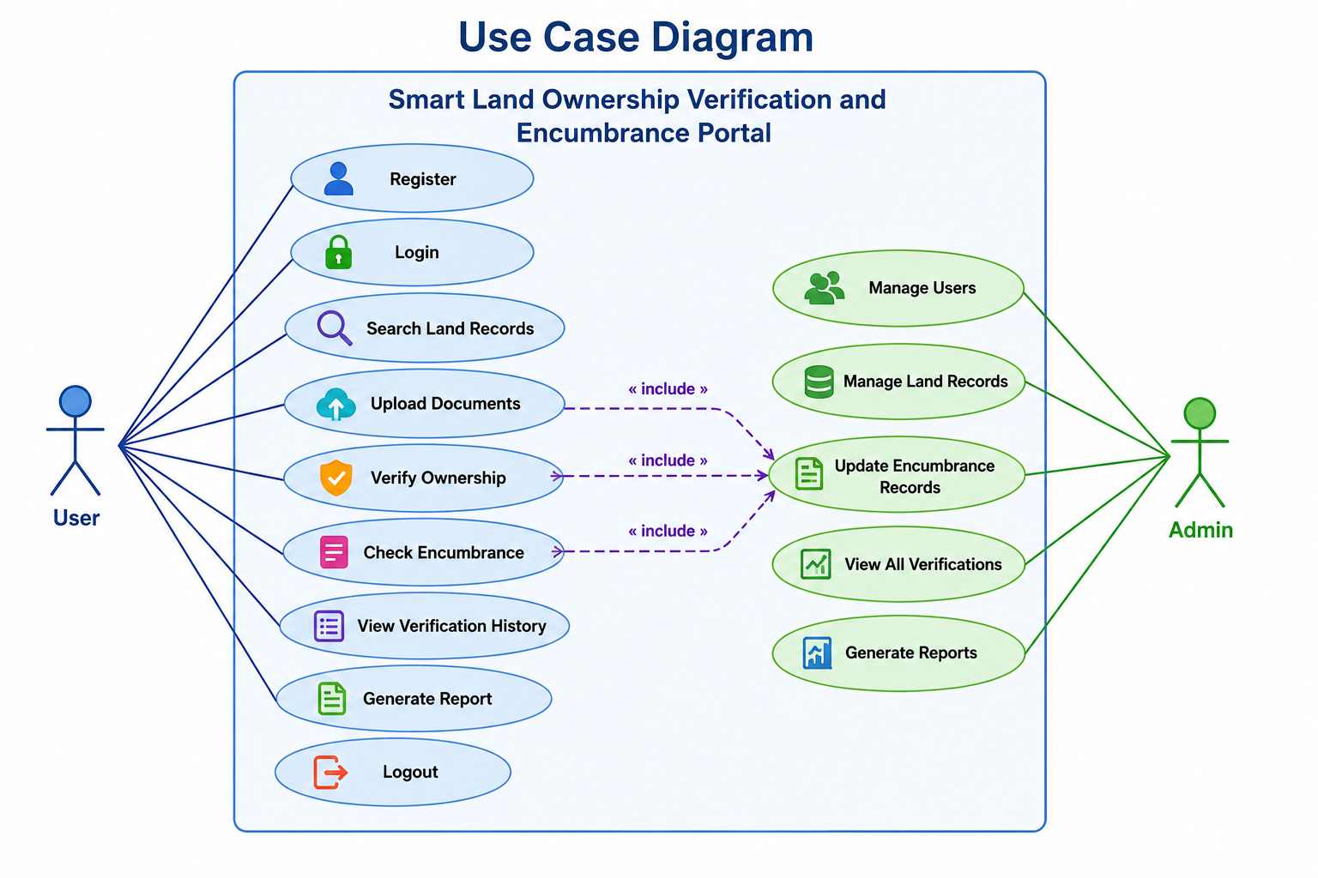

  - Activity Diagram

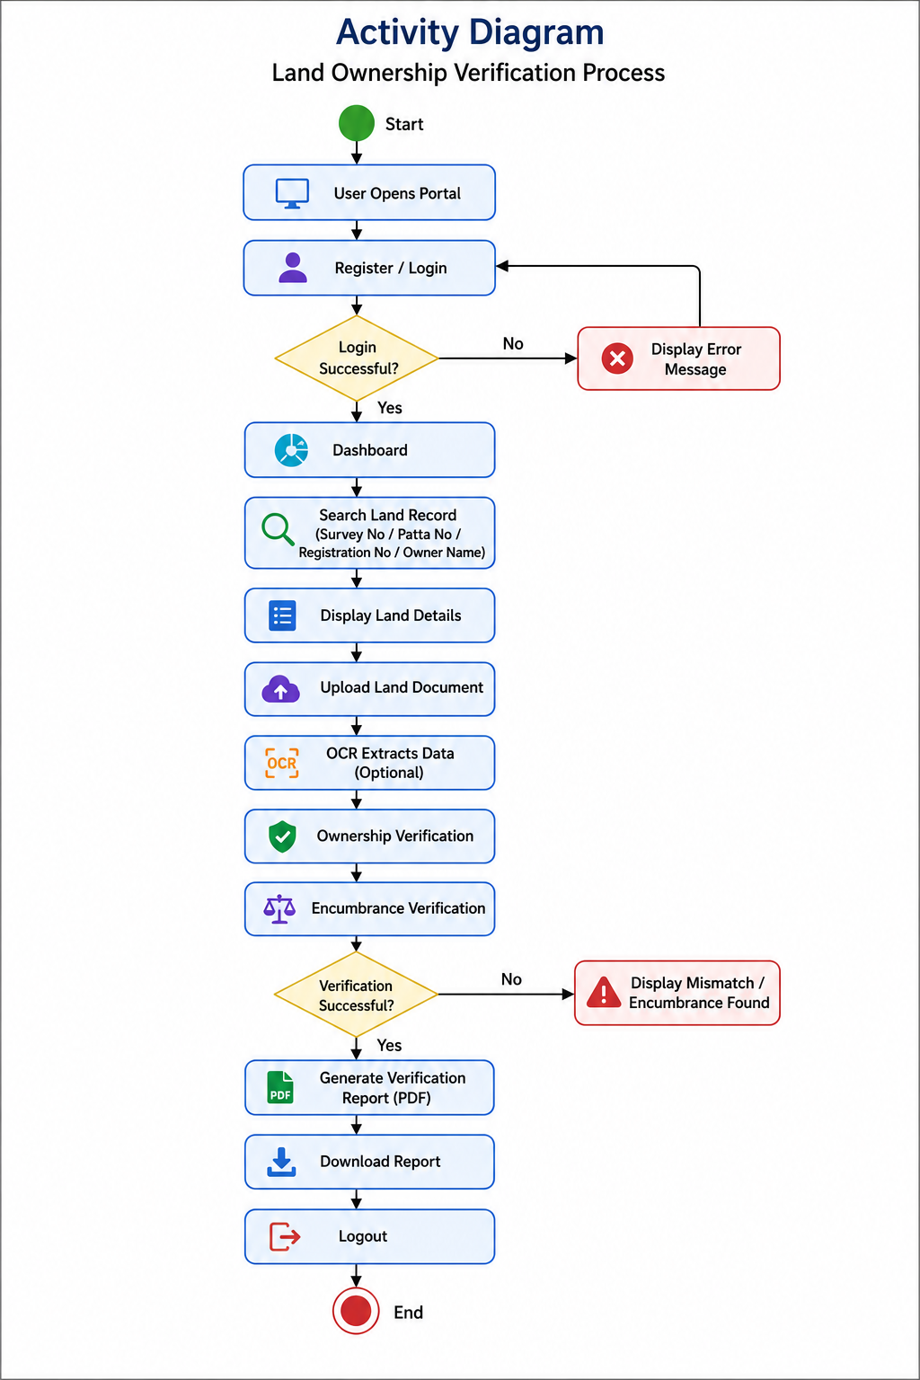

  - Sequence Diagram
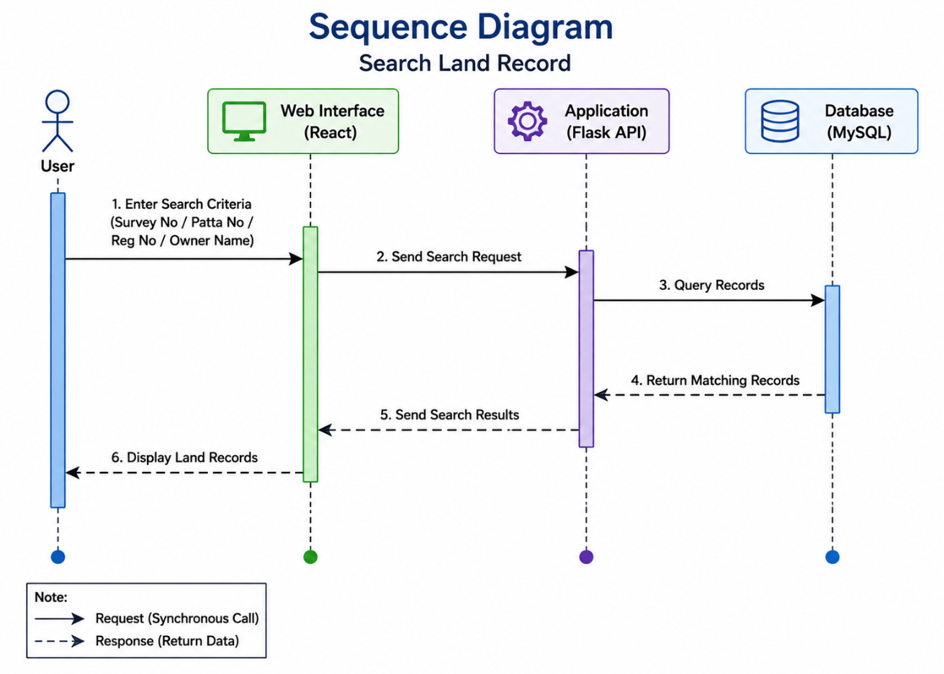

  - ER Diagram

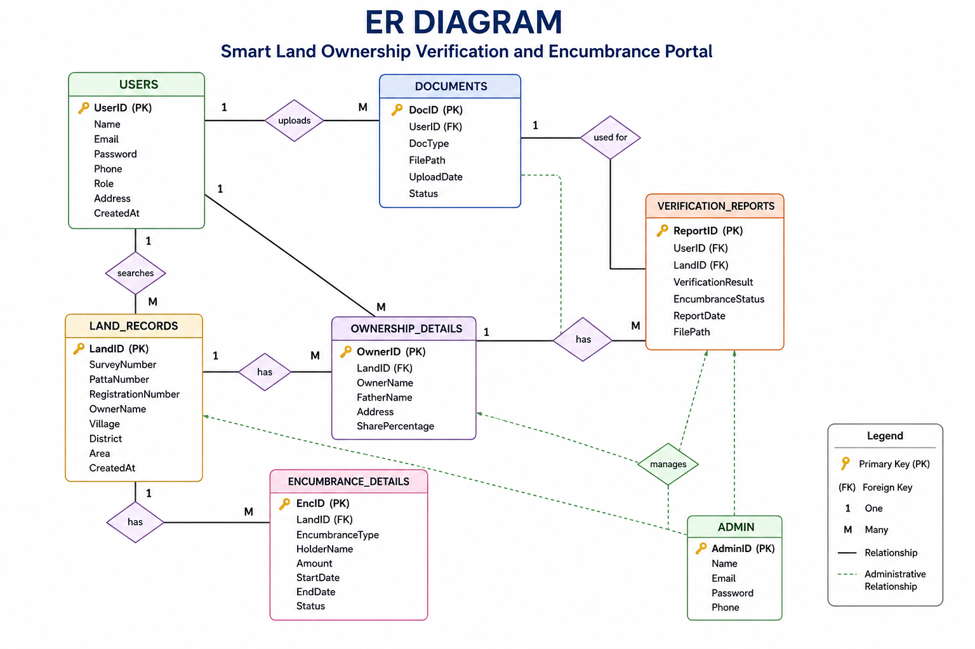

  - DFD – Level 0and Level 1

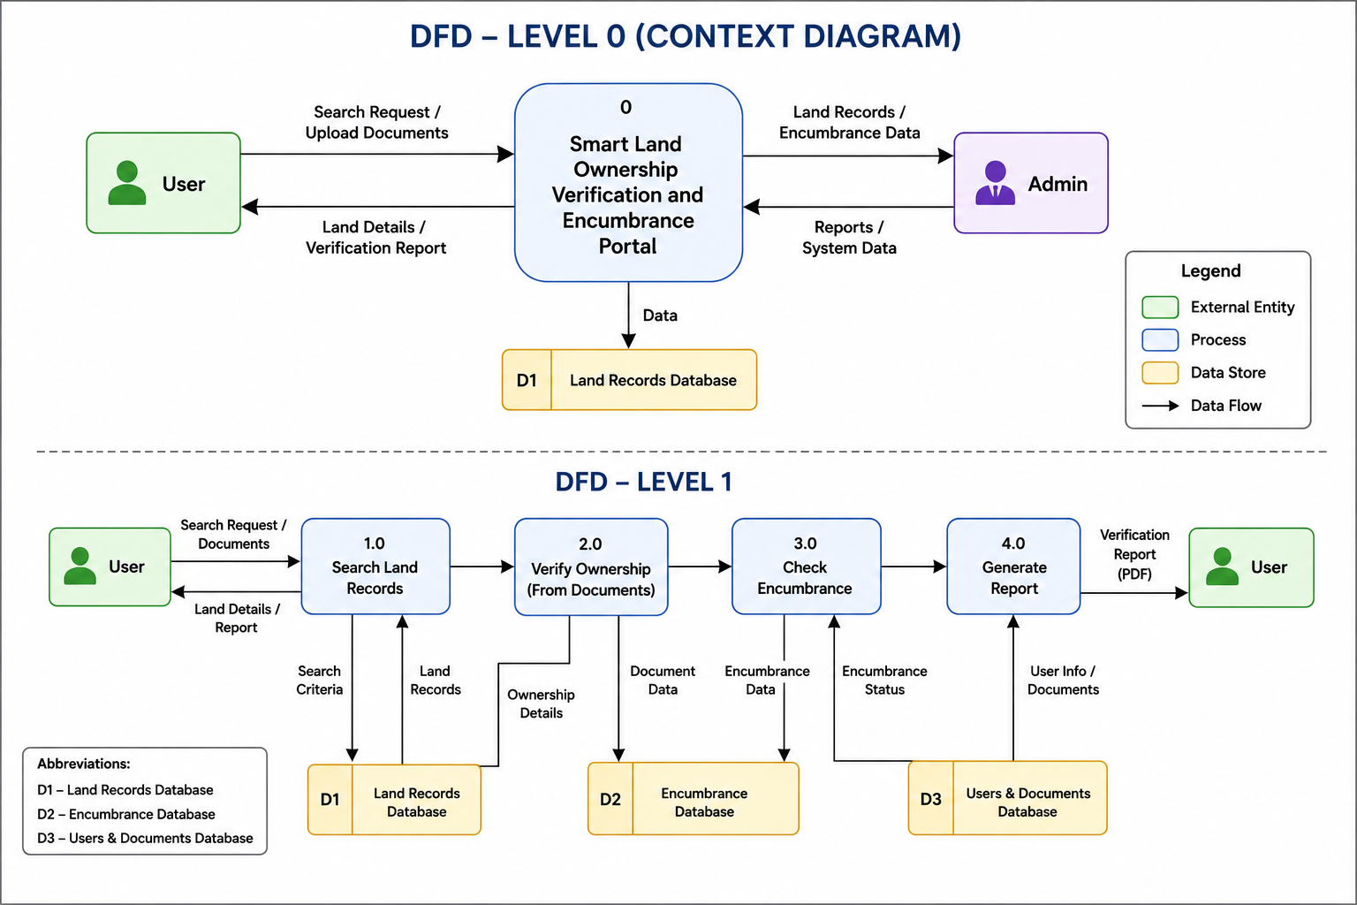

  - System Architecture Diagram
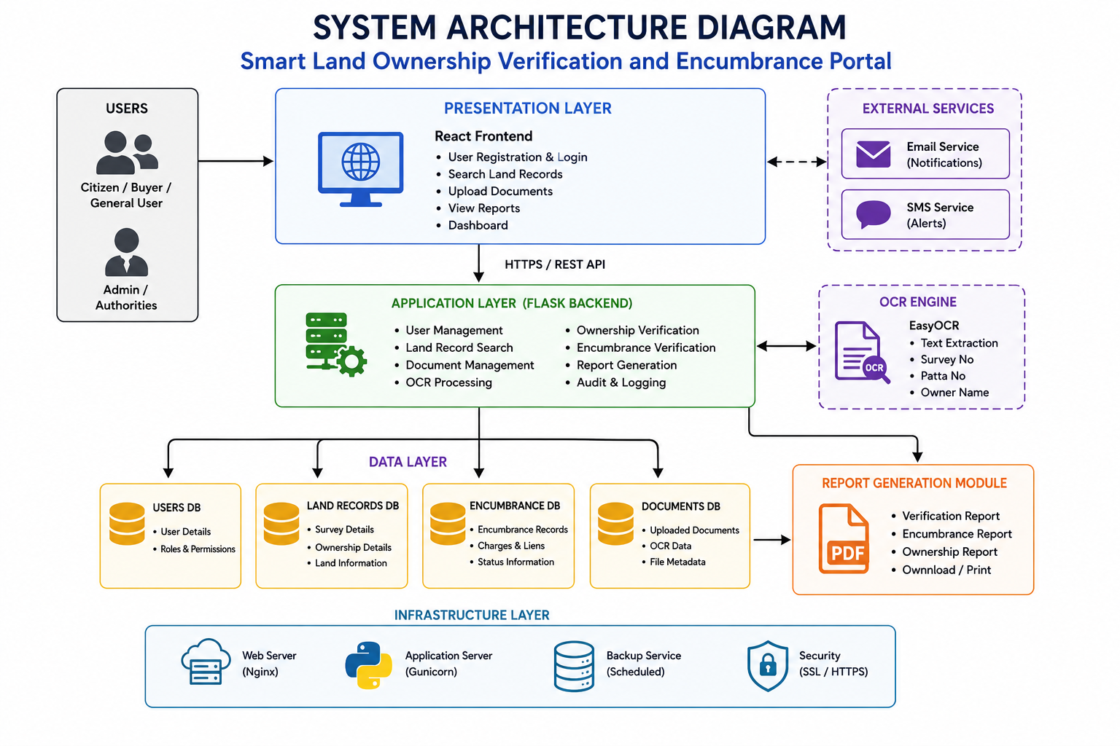

Appendix B:

The following issues and limitations have been identified during the requirements analysis and development of the Smart Land Ownership Verification and Encumbrance Portal. These issues may be addressed in future versions of the system.

Issue ID | Issue Description | Status
ISS-01 | Integration with real government land record databases is not implemented. | Future Enhancement
ISS-02 | OCR-based extraction accuracy may vary depending on the quality of uploaded documents. | Under Consideration
ISS-03 | AI-based fraud detection is not included in the current version. | Future Enhancement
ISS-04 | The system currently supports only web-based access and does not include a mobile application. | Future Enhancement
ISS-05 | SMS and email notification services are not implemented. | Future Enhancement
ISS-06 | Multi-language support (Tamil and English) is not available in the current version. | Future Enhancement
ISS-07 | GIS map integration for location-based land search is not implemented. | Future Enhancement
ISS-08 | Digital signature verification is not supported in the current system. | Future Enhancement
ISS-09 | Blockchain-based land record security is not included in the current implementation. | Future Enhancement
ISS-10 | Cloud deployment and scalability enhancements will be considered in future releases. | Future Enhancement

